- Download SBCL from the website at https://www.sbcl.org/platform-table.html
- Install SBCL with the installation file (sbcl-2.5.9-x86-64-windows-binary.msi).
- Check the system environment variable-path, if “C:\Program Files\Steel Bank Common Lisp\” is added through the installation steps. If not, add this path.
- Install Common Lisp extension in VS Code.
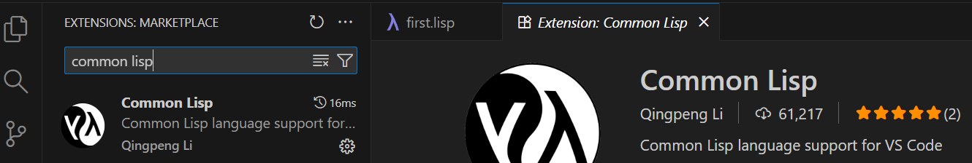
- Open a folder as the workspace.
- Create a simple file first.lisp. (format t “Hello world.”)
- Open terminal in VS Code. Run “sbcl –script first.lisp”.
Note: if SBCL is working in VS Code, restart VS Code or restart Windows.

